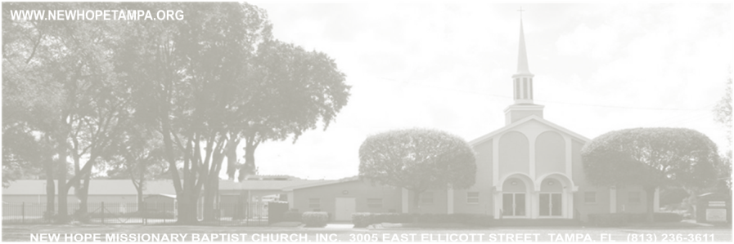

Administration
Entry Doors (5)
Admin Offices (3)
Kitchen (1)
Janitorial Closets (2)
Pantry Room (1)
Storage Rooms (4)
Tables seating (4760 Sq. for seating)
- Round (40)
8 chairs per table 60inch
- Rectangle (5)
10 chairs per table 8 ft long
Sound room (1)
Table seating 320 people
Stage (11 x 54’5)
Community hall (1) 79’4 x 60
A/C Unit (3)

Pastor, Clerk, Admin Asst
Conference Room (1) Size 15’5 x 15’5
Bathrooms
Men (3)
Women (3)
Men/Women (1)
Dressing Room
Men (1)
Women (1)
Class Rooms
Room (1) Size 13’4 x 12’5
Room (2) Size 13’6 x 12’5
Room (3) Size 15’2 x 12’5
Room (4) Size 14’2 x 12’5
Room (5) Size 12’5 x 12’5
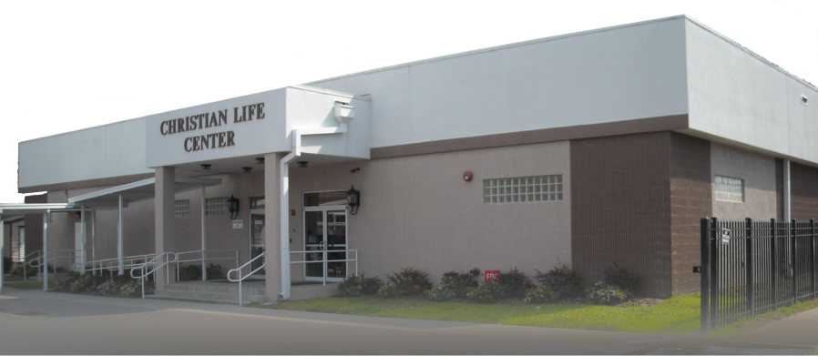
Dining Room (1) Size 16’5 x 16’2

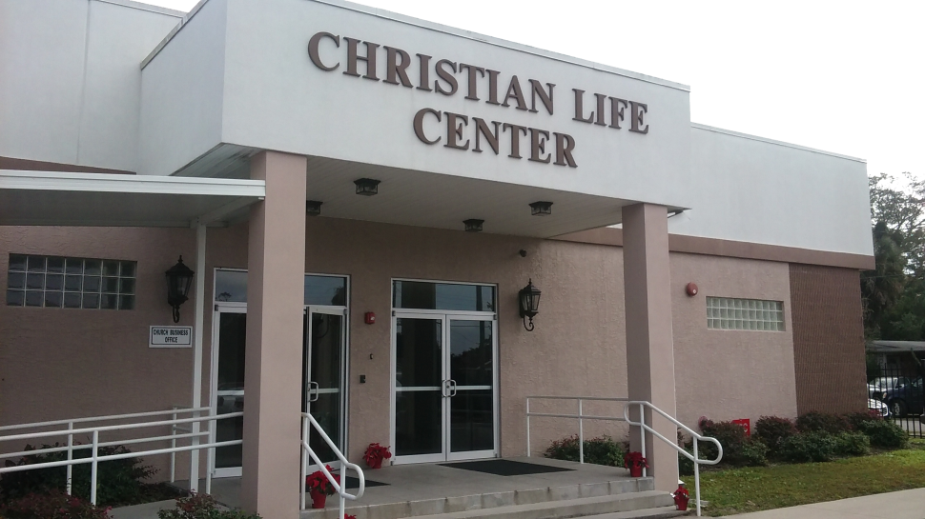

C.L.C. Features:
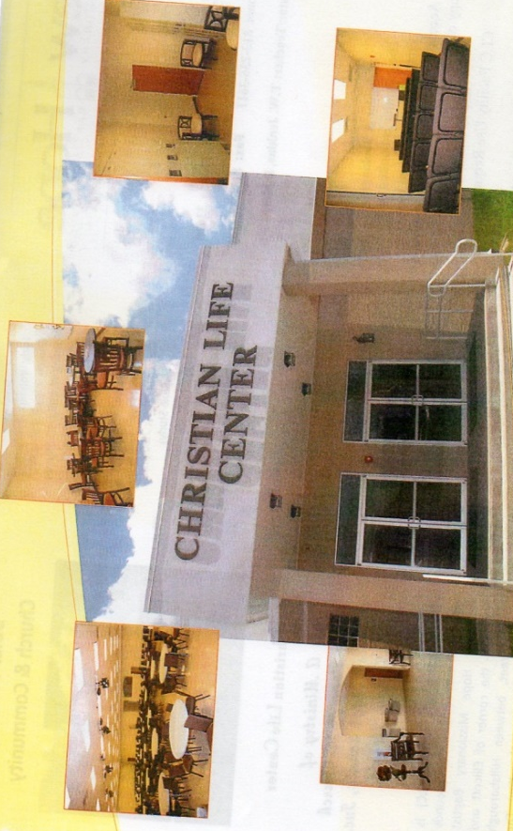
This beautiful facility features 7 classrooms; a large fellowship hall; a stage; audio/visual system; a large kitchen with dining room area; 7 restrooms; women and men dressing areas; two showers and a conference room.
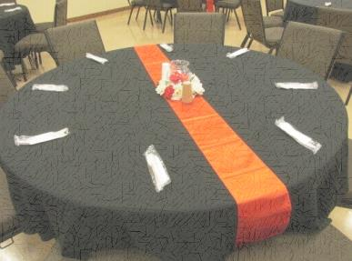

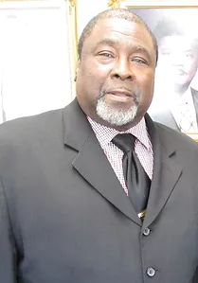

CALENDAR & BOOKINGS:
THE CALENDAR IS BOOKED ON A FIRST-COME-SERVED BASIS.
FOR A COPY OF THE C.L.C. USAGE POLICY,
FEE STRUCTURE AND OBTAIN A CLC FACILITY USE REQUEST FORM.
DIRECT QUESTIONS TO: BROTHER RALPH WYCHE 813-650-4413
BUSINESS HOURS ARE 8 A.M. TO 4 P.M. MONDAY THROUGH FRIDAY.

